SESSA C68, hull no. 11 / 2012
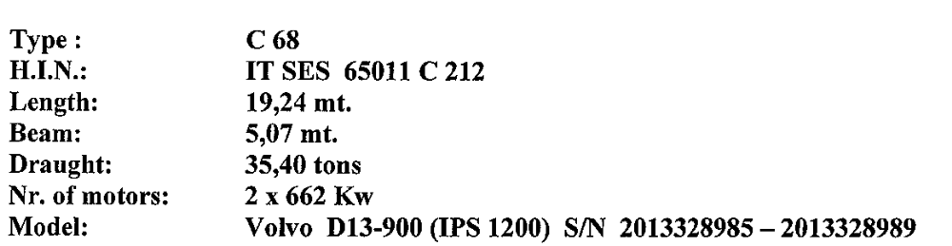

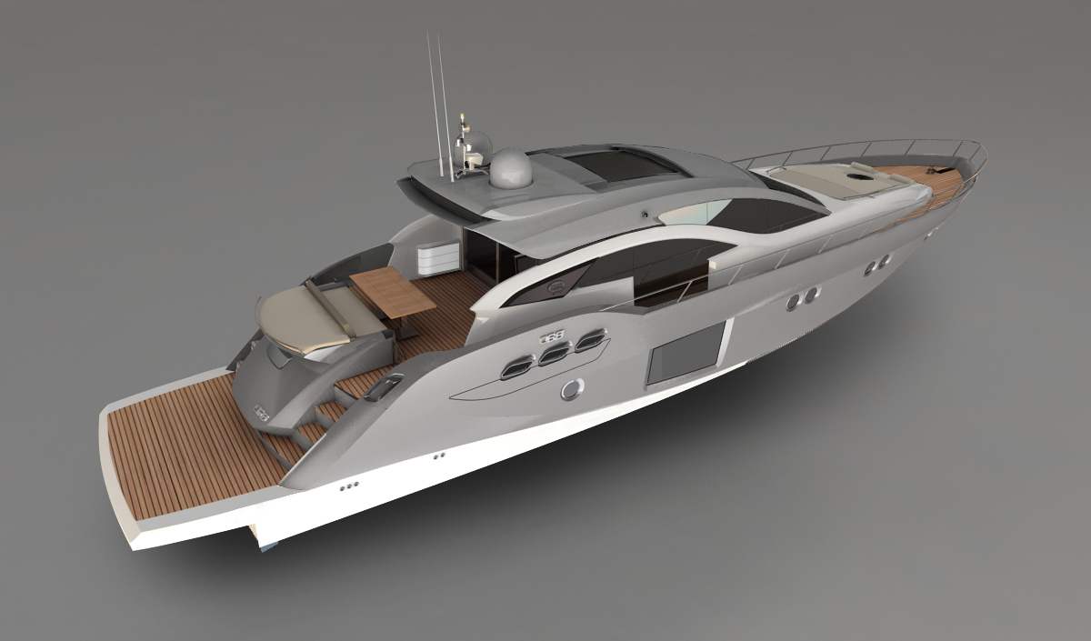

Ns. DDT VENDITA Nr. 18197 del 26/06/2012
C68 2 x VOLVO 1200HP - IPS3
MATR. MOTORE SX 2013328985
MATR. MOTORE DX 2013328989
MATR. IPS SX 3950001062
MATR. IPS DX 3950001063
XTRA OPTIONS
2x GPS Garmin 4012
Autopilot Garmin GHP 10V Complete + IPS interface
Radar Garmin GMR 18 HD
Garmin Airmar NMEA 2000
VHF Garmin
Depth Finder GSD 22
GMI 10 + GSM 10 with transducer DST 800
Underwater world camera PAL 90 degrese
AIS 600 signal to show position of the boat
Satelit EPak 4 x TV / 2 TV + 2TV /
2x Satelit Epak empty
Bose Lifestyle V35 / have to be installed to the overhead
VIP cabin TV Samsung DVB-S
Master cabin TV Samsung LED 32' / 230V / DVB-S
Guest cabin TV Technisat 22' 230/ 12V DVB-S customer /
Hard Top metalic grey with satelite 2 pcs
Cupboard in Guest room
Bifocal light metalized in Hard Top

Volvo DPS systém (el.anchor – IPS version only)
Upgrade hull metalizzed painting
Underwater lights
Bow teck on sides
Main saloon furniture with mirrored Tv and ice maker
Main saloon leather sofa
Galley Wine Cellar
Cabins wood flooring
Master cabin bathroom wooden sliding doors
Main cabin bathroom resin decorated „Gobetto“
Main bath chromotherapy
Name VOYAGER
Set of glasses
Electric shore power cable storage systém
Cockpit electronic bimini
Cockpit BBQ
Upgrade Clima Tropic 72 000 BTU
Crew cabin air conditioning 2 000 BTU
Walvac (cabin vacuum systém)
Dischwashing machine
Washing and Drying machine
Safe box
Bow electric cooler chest
Bow sunpad manual bimini
Outside windows covers
Mirror on the wall in guest cabin
Cockpit cabinets 2 pcs white frame & grey inside
Generator ONAN 20,1 KW - upgrade generator
Fresh water maker Spectra Water makers Newport 700MKII
Inverter 2,5 Kw
Interier COCOA with VINATGE version
--------------------------------------------------------
Tender Zodiak 320 + engine Suzuky 9,9 Hp new generation
2x Rescure island Arimar Offschore
Epir boje
Garmin VHF (handheld)
Solar sails

