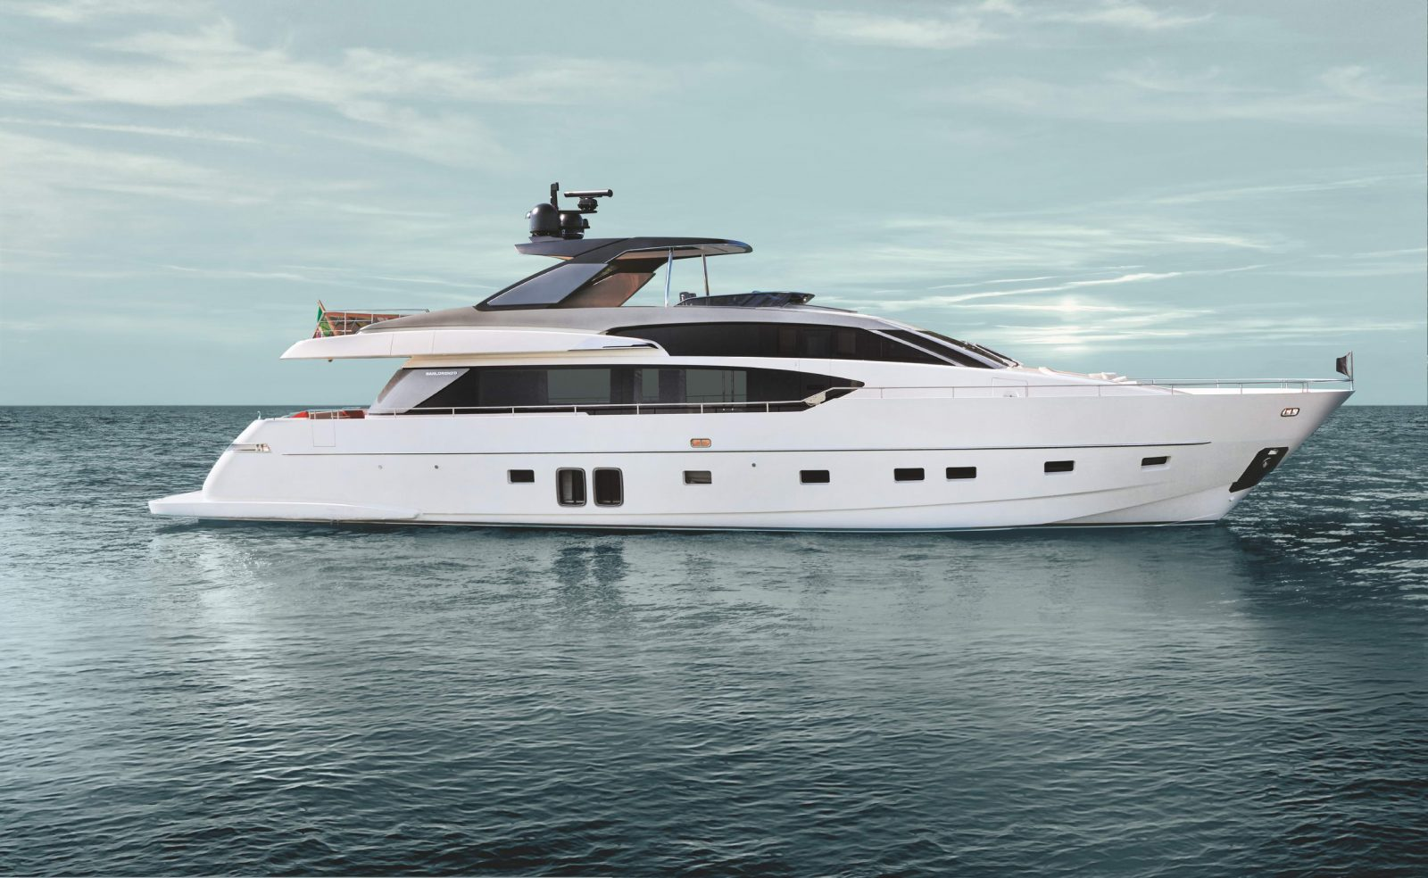

SANLORENZO SL86

YEAR : 2018
L.O.A. : 26,76 m
BEAM : 6,35 m
DRAFT : 1,90 m
DISPLACEMENT : 82 tons (laden)
FUEL : 8400 litres
WATER : 1700 litres
ENGINES : 2 x MTU 12V 2000 M96
HOURS : 720
FLAG : Italian
LOCATION : Tyrrhenian Sea
PRICE : €5.190.000

All particulars are believed to be correct, but not guaranteed.

LAYOUT:

The San Lorenzo 86 is combining signature styling with new innovations.
The stairway to the flybridge has the steps sided by two plate glass and staircase is no longer a box, but it is still in the salon like a piece of art.
The aim is to optimize and maximize all the spaces and to enrich them with natural light.
In the main deck it´s located the big saloon with the dinnig room, kitchen and a courtesy bathroom.
At the Lower deck we find the 4 main cabins and 2 crew cabins plus the 5 bathrooms.

NAVIGATION:

Radar
Automatic pilot
VHF – DSC
AIS
GPS
Plotter
Depth sounder
MTU joystick for engines (bow thruster and stern thruster)
3 electric motors control

EQUIPMENT:

Hydraulic gangway
Full teak including fly
Electric Hard Top
Full air conditioning
Stern garage for tender
Electric winches
Bow thruster
Aft thruster
Complete sundeck cushions
Mobile bar on the fly

All particulars are believed to be correct, but not guaranteed.

Electric stabilizers at anchor and dynamic
CCTV with n. 2 cockpit cameras and n. 1 pan & tilt in the engine room
Fly camera
Battery charger
Touch screen display in the captain's cabin
Third fixed cockpit command station
Inverter for service batteries
Teak bow dinette
Underwater lights
Blackout roller blinds in all cabins
Bow table convertible into sundeck
Air conditioning

AUDIOVISUAL

Speakers
TV Satellite antenna
TV (Saloon and cabins)
Home theatre
DVD

DOMESTIC

Dishwasher
Washing – Dryer machine
Dryer
Oven
BBQ
Microwave
2 Fridge
Wine cooler
Water maker
Icemaker

All particulars are believed to be correct, but not guaranteed.

LAYOUT:

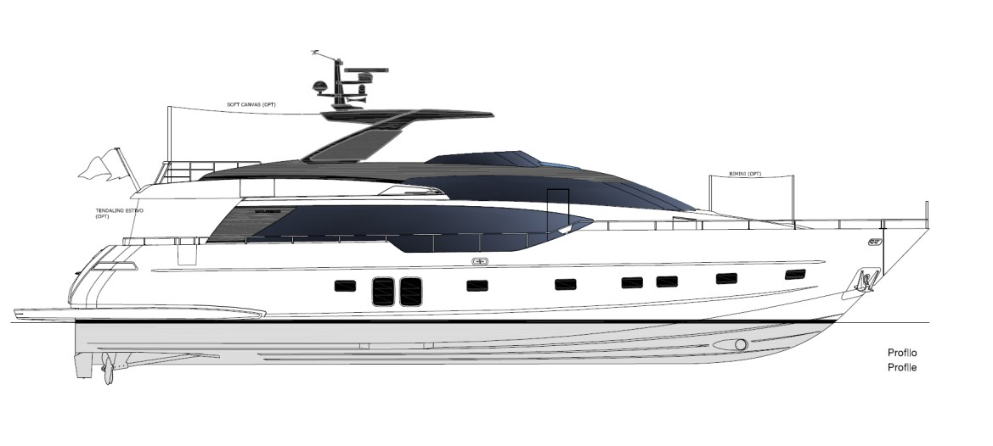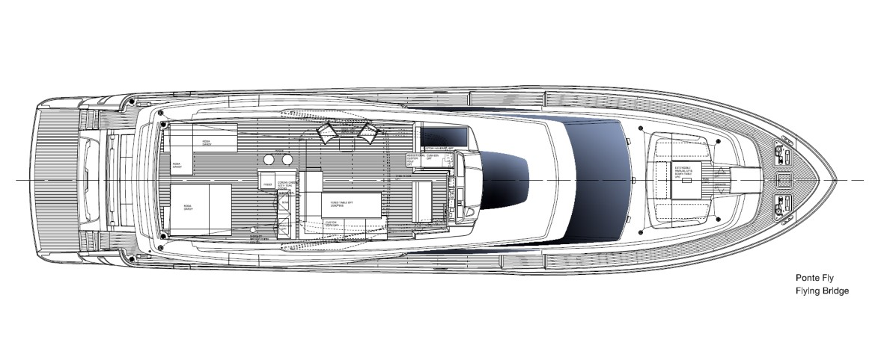

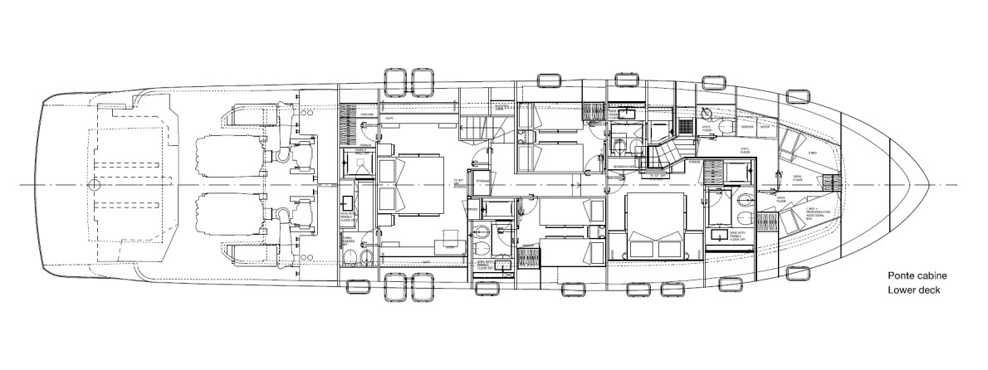

All particulars are believed to be correct, but not guaranteed.

