FERRETTI 670
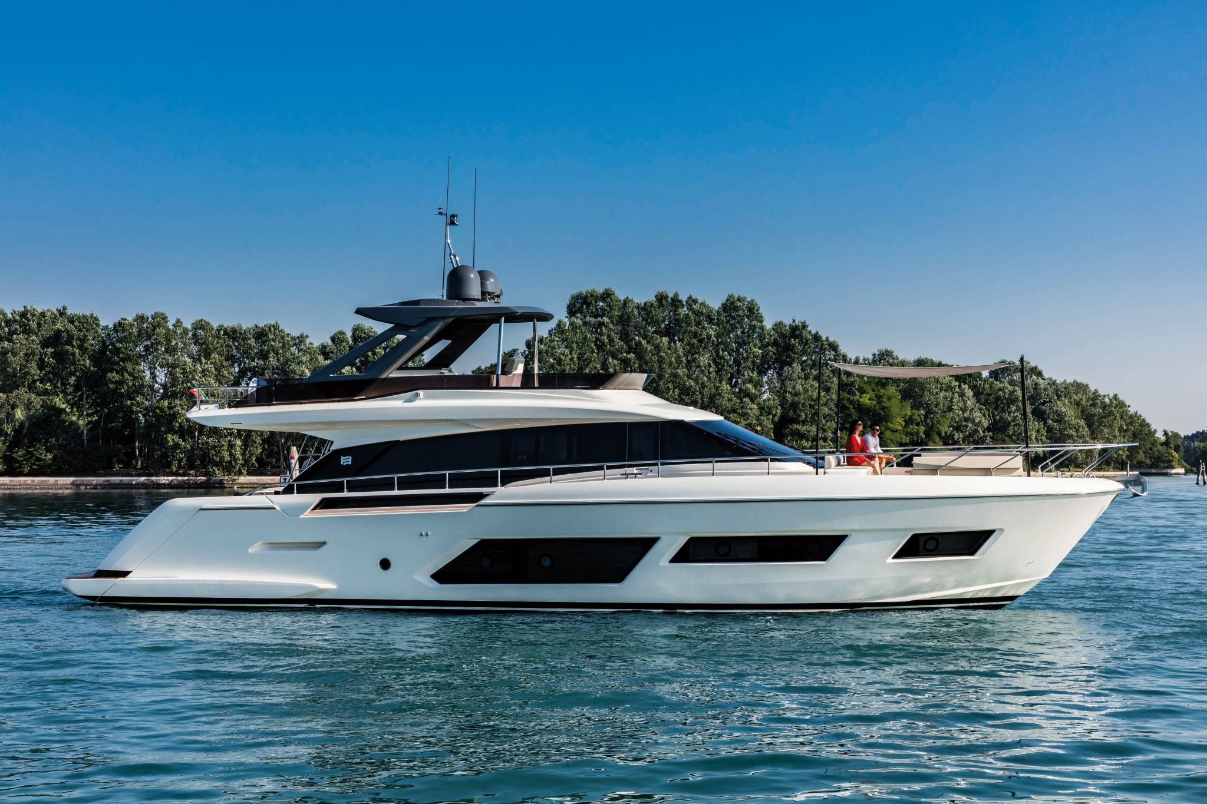

This fantastic vessel makes a captivating impression with her outstanding use of space. The fabulously luminous interiors and modular external areas hold particular appeal. Her latest-generation technology fashions a matchless cruising experience amid some truly iconic design. This is a yacht that makes room for beauty.

YEAR : 2023
L.O.A. : 20,24
BEAM : 5,38 m
DRAFT : 1,64 m
DIESEL : 3800 litres
WATER : 1000 litres
ENGINES : 2 X MAN V8 1200 Hp
HOURS : 50 h
FLAG : British
LYING : Italy
PRICE : € 2.941.511 VAT not included

FERRETTI 670

LAYOUT:

This 670 comes with 4 cabins and 4 bathrooms. The owner suit it is in the centre of the boat, and next to it is a study. On the main deck, the 670 has a wonderful outlook from the saloon lounging areas, with the galley forward.

NAVIGATION:

SIMRAD NAIS500
SIMRAD DISPLAY UPGRADE IN MAIN HELM POSITION AND IN FLYBRIDGE POSITION.

EQUIPMENT:

Hard Top without cover
Super Tropic air conditioning (salone, cabins & crew)
Generator Upgrade
Shore fresh water intake
Teak on the spoiler
Digital chain counter each
TABLES AT BOW CONVERTIBLE INTO SUNPAD PAINTING OF NAVIGATION EQUIPMENTS black
Fly bridge table in natural teak
COURTESY LIGHTS FOR OUTDOOR AREAS
Ambient lights
ELECTRIC CURTAINS+BLACKOUT IN MASTER CAB (4CAB)
Pilot seat in leather -diff. searchlight electrically controlled (big rectangular)
Comfort shower at the stern
SMART CONTROL FOR CURTAINS AND LIGHTS
Inverter/battery charger Mast Mass combi 24V 2500W 60A

Salon curtains electrically-driven lifti Watertight door access from crew zone to engine room
Multistandard sockets - diff std
Engine / bow thruster Joystick control system
GYRO STABILIZER DPS for joystick stern thruster 10,7 HP(double propeller) Monitoring upgrade: generator data monitoring and A/C monitoring and control Maneuver external color
TVCC: internal color camera additional
TVCC: external color camera, additional cad.
Primer under the antifouling autoidentification system
AIS receiver
Foxtel box cables predisposition
Dinette sofa diff. (Home Decor Must 001)
Salon's sofas diff. from standard (Home Decor Must 001)
Outdoor fabric diff (Diamante col. Snow DIA-6601)
Parquet custom flooring for main deck (Mardegan Spazzolato Harlem)
Galley top diff. from std (Corian Deep Caviar)
Shower wall in master bathroom diff. (Florim I Classici di Rex Calacatta Gold)

FERRETTI 670

AUDIO VISUAL:

TV: electric raising device for TV 37"-43"
TV 43" IN SALON
TV 43" IN MASTER CABIN
TV 32" IN VIP CABIN
TV 24" IN GUEST CABIN DX
PREMIUM SOUND IN EXTERNAL AREAS JL
Premium sound in salon
Predisposition nr.6 underwater lights
PC: additional WI-FI access point
Predisposition backlit boat name TVCC visualizer more than two cameras

DOMESTIC:

Gaggenau grill on the fly bridge
Refrigerator on the fly 50 liters cooler drawer in saloon
Dishwasher 6 COVERS washing/drying machine 42 cm 5 kg
Ice maker with independent water tank roll blind in lower deck cabins
WATERMAKER (180 l/h) W/CTRL AT MAIN HELM

LAYOUT:

