CUSTOM LINE 112

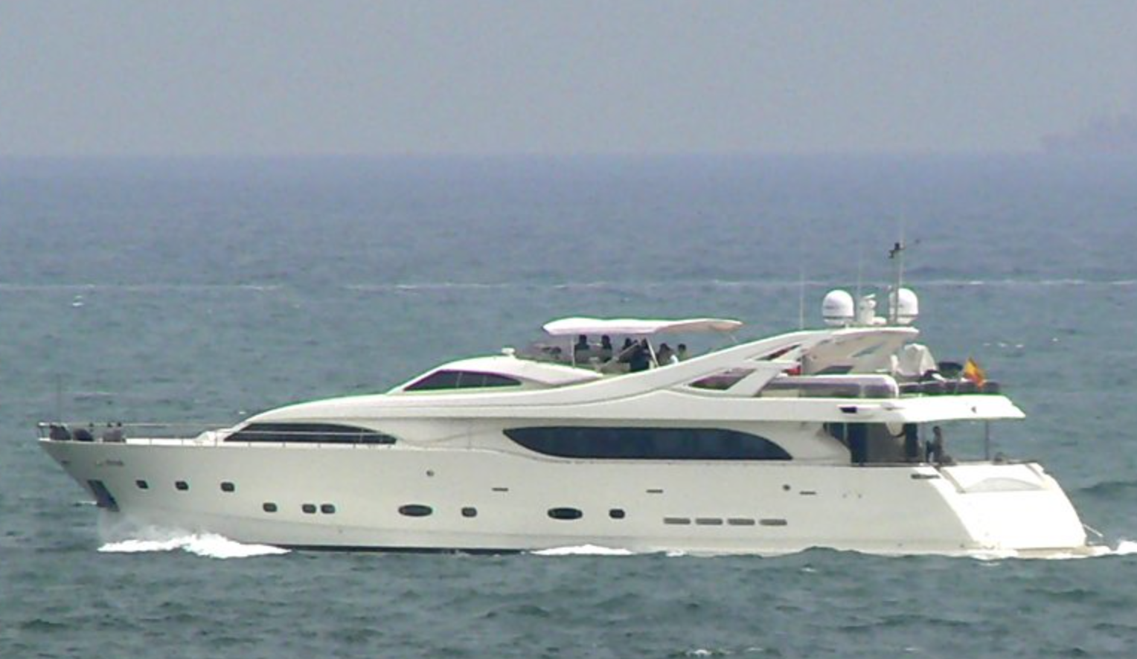

“CAMARIK”
Custom Line 112 built 2005 with 2 x 2774 hp MTU. Great large spaces with 5 cabins with accommodation for up to 11 guests plus 3 crew cabins. One owner from new. Interior completely renovated.

YEAR : 2005
LENGTH TOTAL : 34 m
BEAM : 7.08 m
DRAFT : 1.85 m
WEIGHT (LOADED: 130 ton
DIESEL : 20.000 litres
WATER : 3.000 litres
ENGINES : 2 x 2774 MTU 12V 4000 M90
HOURS : 2700 (October 2023)
FLAG : Española
LYING : Barcelona
PRICE : €3.350.000 ex Vat

All particulars are believed to be correct, but not guaranteed.

CUSTOM LINE 112

LAYOUT:

Accommodation for 11 guests in 5 cabins all ensuite plus 3 crew cabins. Main cabin on main deck with large bed, walk in wardrobe and bathroom, lower deck 3 cabins with double bed and 5th cabin with 2 single beds plus pullman berth. Crew layout with crew mess, 4 cabins and 4 bathrooms. Large saloon and dining area next to completely equipped galley. Day head. Fly bridge with access from raised helm station and from cockpit, aft area with sunbeds, jacuzzi, sofa and table plus fly helm.

NAVIGATION:

Radar antenna open array Furuno 72 miles
GPS antenna
Comunications antennas
3 displays for navigation radar, plotter, Depth etc
Display for alarms
Naviop display 15” for boats controls
Display for CCTV with camaras on stern, sides, control room and engine room
Automatic pilot Simrad AP50 IMO with repeater on fly
Depth
Radio VHF with repeater on fly
Radio SSB Furuno DSC FS1570
Epirb
Tridata
Magnetic gyroscopic compass
Rudder angle indicator
Tridata and radio VHF repeater in crew mess
GSM phone system with satellite antenna
Electronic engine controls
Emergency rudder with indicator in control room
2 domes on radar arch

All particulars are believed to be correct, but not guaranteed.

CUSTOM LINE 112

EQUIPMENT EXTERIOR:

Teak decks
Bow and stern hydraulic thrusters
Bimini sun top on fly bridge
Lights with dimmers
2 anchor winches with chain 16mm 100m and 110m with 2 anchors 160 kg
2 stern mooring winches
Garage on bow with electric door for storage
Aft garage with electric door converting to large swim platform
Crane for tender 800kg
Tender with out board engine
Seabob
Furniture with jacuzzi on flybridge
Electric side doors with access to sidewalks
Saloon door electric
Hydraulic pasarelle
Carbon swim ladder

EQUIPMENT INTERIOR:

2 generators Kohler 55 KW (5000 and 5300 hours)
Air conditioning throughout all boat 188.000 BTU with 3 compressors
Electric curtains in saloon and main cabin
Wood floor on main deck
Cero speed gyro stabilizers Mitsubishi
Shore power with automatic battery chargers
Fire and smoke system
2 water heaters
Alpha Laval system for fuel treatment
Black water system with discharge
Electric WC
Water purifier
Counter tops and floors in bathrooms of marble

All particulars are believed to be correct, but not guaranteed.

CUSTOM LINE 112

AUDIO VISUAL:

Sound system in saloon with speakers inside and exterior
Sound system in galley, wheel house, fly bridge and all guest cabins
TV in saloon, owners cabin and guest cabins
Satelite TV antenna with decoders in saloon and cabins

DOMESTIC:

Galley with:
- Ceramic hob x 2 and frier
- Fridge and freezer 2 doors
- 2nd fridge
- 2nd freezer
- Oven
- Micro wave oven
- Dishwasher
- Double sink
- Wine fridge
- Ice maker
- Trash compactor

Bar furniture in saloon with fridge and ice maker
Wet bar on flybridge with fridge, grill and wash basin
Washing machine and drier Miele in crew mess
Fridge and freezer in crew mess

All particulars are believed to be correct, but not guaranteed.

CUSTOM LINE 112

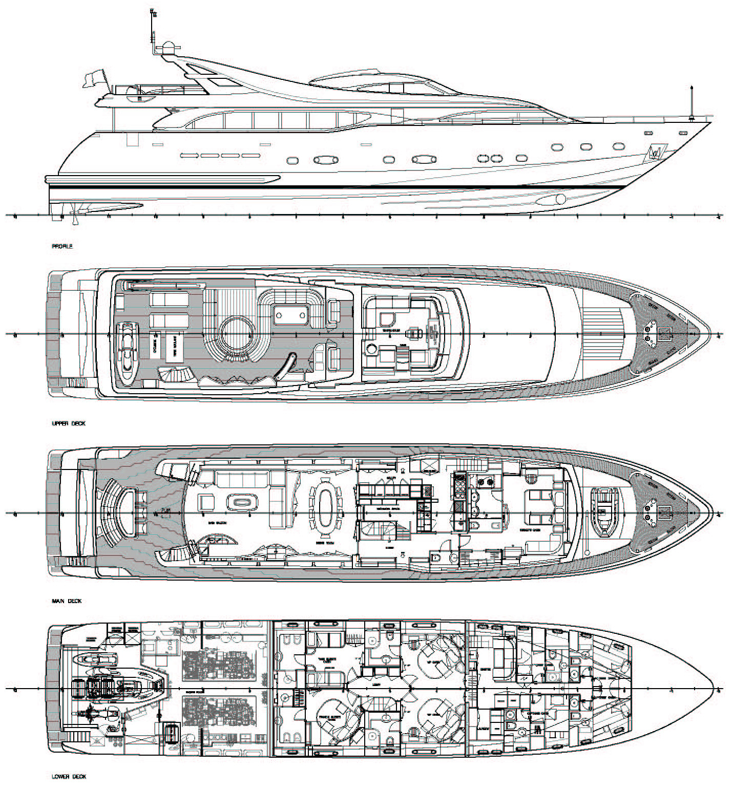

All particulars are believed to be correct, but not guaranteed.



Tel: +34 952810066 Marbella, Barcelona, Mallorca, London www.venturayachts.com

